Geometry: Unit 1, Lesson 9

- Three angles are shown: $∠DRF$, $∠DRH$, and $∠FRH$. If $m∠DRF=172°$ and $m∠DRH=49°$, what is the measure of $∠FRH$?
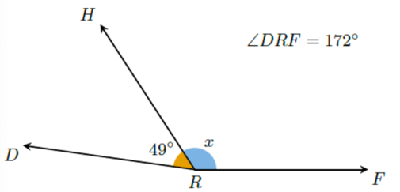

$$123°$$

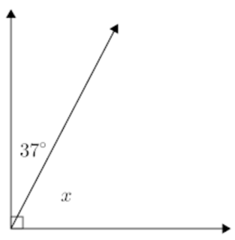

- Two angles are shown. What is the value of $x$?

$$53°$$

- What geometric tools are used when copying an angle?

Compass and Straightedge

